III B. TECH I SEMESTER REGULAR EXAMINATION - 2022
MACHINE LEARNING
(CSM)

Time : 3 Hours Max. Marks : 70
___________________________________________________________________________________________________________________________________________________________________________________________________________________________________________________________
Note : Answer ONE question from each unit (5 × 14 = 70 Marks)
~~~~~~~~~~~~~~~~~~~~~~~~~~~~~~~~~~~~~~~~~~~~~~~~~~~~~
UNIT-I
1. | a) | Define Machine Learning and Describe the process of estimating  f? | [7M]
1. | b) | Describe the process of assessing Model’s accuracy? | [7M]
(OR)
2. | a) | Distinguish between supervised learning and Unsupervised learning. Illustrate with an example. | [7M]
2. | b) | Discuss any four examples of machine learning applications. | [7M]
UNIT-II
3. | a) | Consider the training data in the following table where Play is a class attribute. In the table, the Humidity attribute has values “L” (for low) or “H” (for high), Sunny has values “Y” (for yes) or “N” (for no), Wind has values “S” (for strong) or “W” (for weak), and Play has values “Yes” or “No”.  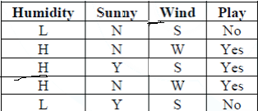  What is class label for the following day (Humidity=L, Sunny=N, Wind=W), according to naïve Bayesian classification? | [7M]
3. | b) | Suppose we collect data for a group of students in a statistics class with variables X1 = hours studied, X2 = undergrad GPA, and Y = receive an A. We fit a logistic regression and produce estimated coefficient,  βˆ0 = −6, βˆ1 = 0.05, βˆ2 = 1.  (a) Estimate the probability that a student who studies for 40 h and has an undergrad GPA of 3.5 gets an A in the class.  (b) How many hours would the student in part (a) need to study to have a 50 % chance of getting an A in the class? | [7M]
(OR)
4. | a) | Compare Linear regression with K-Nearest neighbors. | [7M]
4. | b) | “Restaurant A” sells burgers with optional flavors: Pepper, Ginger, and Chilly. Every day this week you have tried a burger (A to E) and kept a record of which you liked. Using Hamming distance, show how the 3NN classifier with majority voting would classify { pepper: false, ginger: true, chilly: true} | [7M]
   | Pepper | Ginger | Chilly | Liked
  A | True | True | True | False
  B | True | False | False | True
  C | False | True | True | False
  D | False | True | False | True
  E | True | False | False | True
UNIT-III
5. | a) | Explain bootstrap briefly. | [7M]
5. | b) | What are the advantages and disadvantages of k-fold crossvalidation relative to LOOCV? | [7M]
(OR)
6. | a) | Explain model selection techniques in detail? | [7M]
6. | b) | Differentiate ridge regression and lasso regression. | [7M]
UNIT-IV
7. | a) | The dataset in the below Table will be used to learn a decision tree for predicting whether a mushroom is edible or not based on its shape, color and odor.  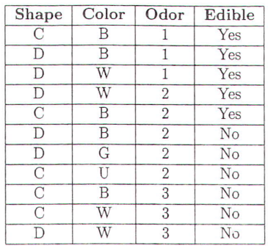  (a) What is the entropy H(Edible l (Odor = 1 OR Odor = 3))?  (b) Which attribute would the ID3 algorithm choose to use for the root of the tree (no pruning)?  (c) Draw the full decision tree that would be learned for this data (no pruning). | [7M]
7. | b) | Consider the table below, which contains data about second-hand Car listings. We want to build a decision tree classifier to predict whether it is an acceptable deal to buy a listed second-hand car. We consider the two classes ‘acc’ and ‘unacc’.  - Calculate the GINI index of the root node of a decision tree with the given training data(first seven rows)  - Build the decision tree using the ID3 algorithm.  - Use the decision tree to classify the unknown points in the table. | [7M]
  No | Pricing | Condition | Seating | Safety | Acceptability
  1 | High | Great | Four | High | Acc
  2 | Low | Good | Four | Low | Acc
  3 | Low | Great | Two | High | Acc
  4 | Low | Good | Two | High | Unacc
  5 | High | Bad | Four | Low | Unacc
  6 | High | Great | Four | Low | Unacc
  7 | Low | Good | Two | Low | Unacc
  8 | High | Good | Four | Low | ?
  9 | Low | Great | Two | Low | ?
(OR)
8. | a) | Explain random forest classifier in detail. | [7M]
8. | b) | Explain Boosting Techniques in detail. | [7M]
UNIT-V
9. | a) | Explain Support Vector Machines Classifier in detail. | [7M]
9. | b) | Explain maximal margin classifier in detail? | [7M]
(OR)
10. | a) | Explain K – Means Clustering algorithm with a suitable example. | [7M]
10. | b) | Explain hierarchical clustering in detail. | [7M]
*** * *

